Creed Creme Café

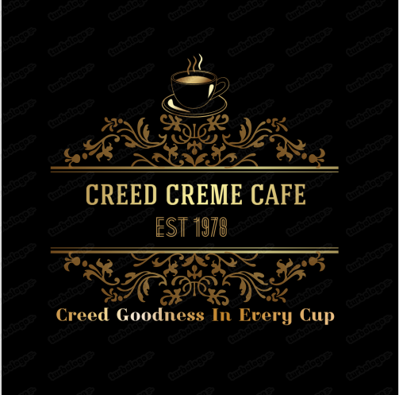

Course: Introduction to Web development

Group Members: Thandiwe Mohlabeng, Tshepo Radebe, Ryan Sibanda, Sisanda Nene, Mbali Ngubentombi, Neo Morontse, Kgaogelo Molepo, Prince Mulovhedzi, Tebogo Baloyi, Junior

Submission Date: 20 June 2025

## PROJECT OVERVIEW:

***Description***:

The creed Cream Café website is a fictional website designed to represent a stylish and modern coffee shop-We Brew Happiness.

Creed Cream Café is a cozy and welcoming coffee shop where comfort meets quality. We serve freshly brewed coffee, creamy lattes, delicious pastries, and light meals made with love. Whether you’re catching up with friends, grabbing your morning coffee, or looking for a quiet space to relax, Creed Cream Café is your perfect spot. Come enjoy the rich aroma, warm atmosphere, and friendly service that make every visit special.

**Main objective:**

At Creed Cream Café, our main objective is to serve more than just coffee — we serve comfort in a cup. We aim to create a warm, welcoming space where every sip feels like home and every bite brings joy. Whether you’re starting your day or taking a welldeserved break, our goal is to be your “daily dose of delight” with handcrafted drinks, fresh treats, and a cozy atmosphere that invites you to stay a little longer.

Our mission is to blend quality, connection, and care into everything we do. From “beans to dreams,” we’re passionate about delivering rich flavours, friendly service, and a relaxing café experience for everyone who walks through our doors.

## WEBSITE STRUCTURE:

Site Map

Our website consists of these main pages:

* Our Menu
* About Us
* General info
* Follow us
* Rewards
* Get In Touch

**Page Descriptions**

1. Home Page

Welcomes visitors with an introduction to Creed Cream Café and highlights the café’s bestselling items or promotions.

2. Operating Hours Section

Tells customers what time each store opens and closes.

3. Menu Page

Displays a list of drinks and food items available at the café. Each menu item includes a name, image, description, and price.

5. Store Locations Page

Provides a list of all Creed Cream Café locations with their addresses, maps, and contact details.

6. About Us Page

Shares the story of the coffee shop, its values, and what makes it special.

## HTML ELEMENTS USED:

**Content:**

* <br>: for in between brakes with in the content.
* <ol> and <ul>: This is for creating unordered and ordered lists.
* <h1> to <h6>: This is the formatting of headings.
* <img>: This was used for the images added onto the website
* <p>: This is for the paragraphs

**Screenshot examples:**

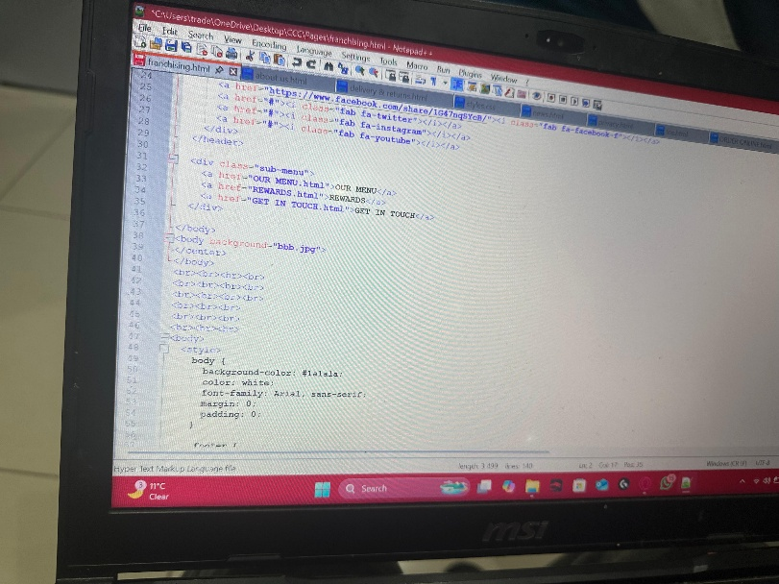

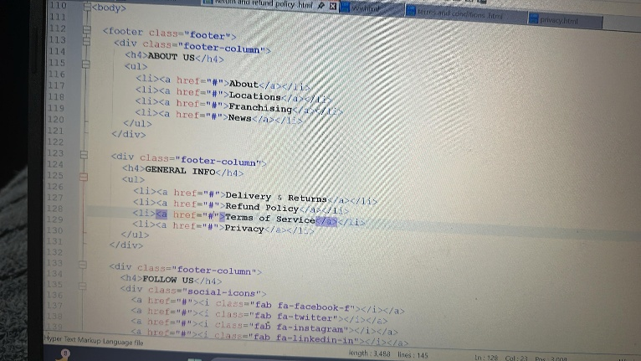

## CSS IMPLEMENTATION:

#### **CSS Properties Researched and Applied**

We went for a more vintage and much warmer theme for the website because the café’s theme is a vintage café. Which explains the use of these codes.

**Layout:**

* display: Used flex display
* margin, padding, justify: This applied for the spacing of content
* width: the sizing of the content

**Font/Literature:**

* font-family: The fonts used are “Arial” from “Sans-serif”
* font-size: The size of the text is 20px
* font-weight: The weight of the font
* letter-spacing: The spacing between letter

**Colour and Visual:**

* color: The colour used to define the text
* background-color: The colour of the background of the website
* border: used for the footer of the website pages

**Colour codes and Designs:**

* color: #f2f2f2f2
* background-color: #2c2c2c
* border-bottom: 1px solid #777
* border-top: 1px solid #777

## Appendix: Github Repository

Our project is available at: <https://github.com/Thandiwe-006>

The repository contains all HTML Files, CSS Files, images, and documentation